**EE513 Assignment**

Name: Hazim Khwaja

Student ID: 21268436

**Physical connection of the RTC module to the I2C bus.** [5%]

A physical circuit connection was done as below:

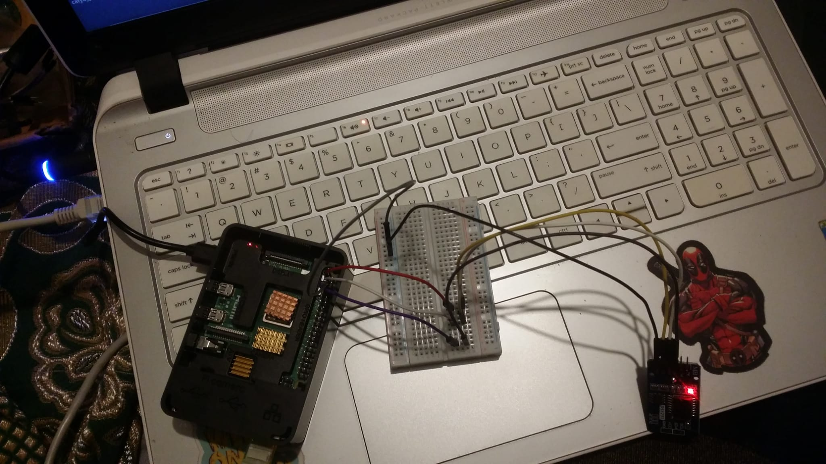

**Discovery and testing of the module using Linux-based i2c-tools**  [10%]

After executing the commands, the following output was received:

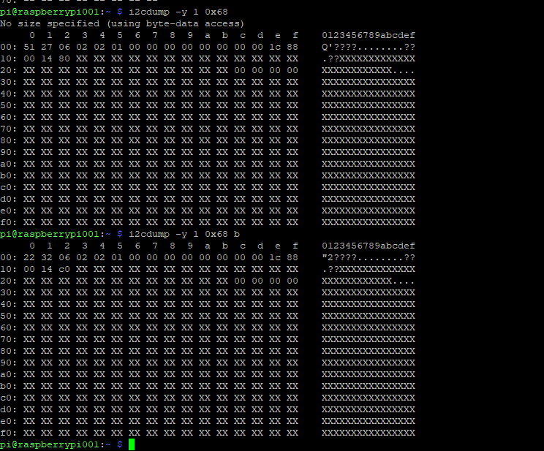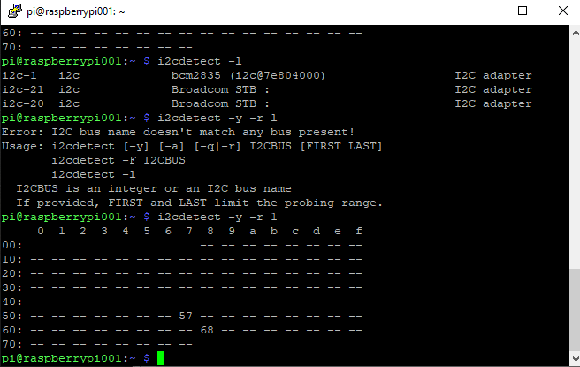

**Design, write and test a C++ class that wraps the functionality described in the DS3231 datasheet, including functionality to**

**Read and display the current RTC module time and date.** [10%]

The output for the current date and time is as below:

(The code from the question is compiled with additional printf statement for date )

**NOTE: I couldn’t get the commit history using git. But in some of my screen grabs at the bottom right corner is the time and date at which the task was completed.**

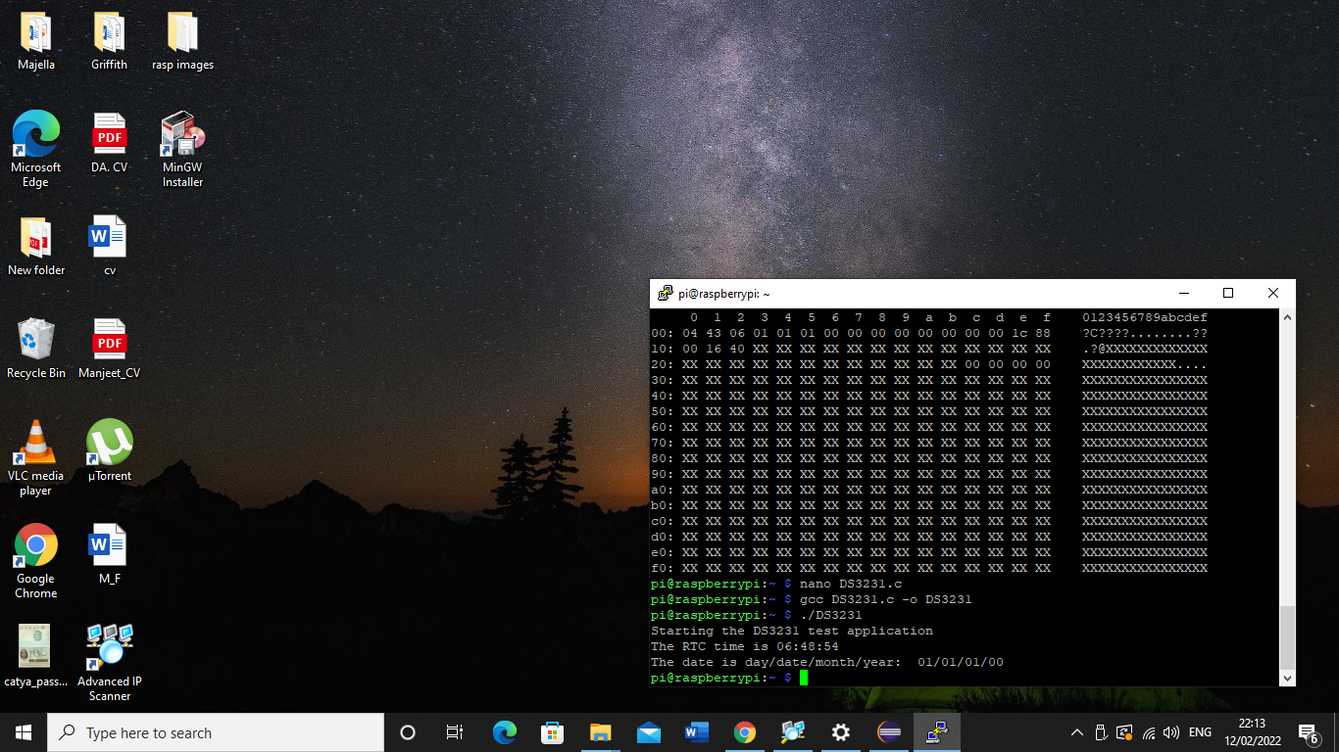

**Read and display the current temperature**. [5%]

The following is the output of the read temperature

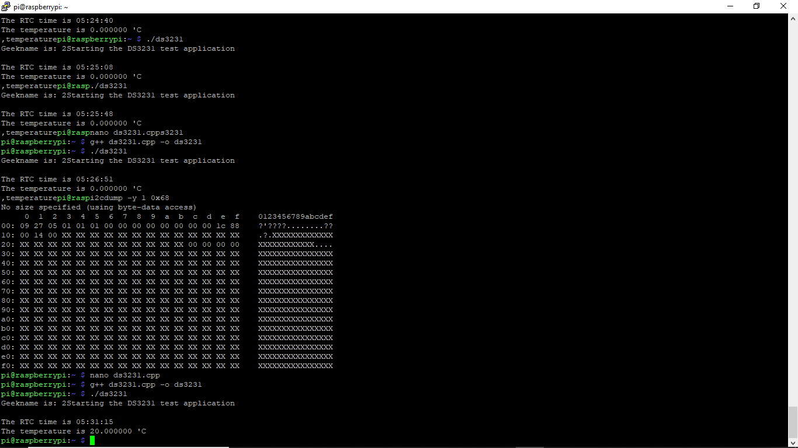

The code can be found at <https://github.com/hazimkhwaja/EE513-Assignment_1/blob/main/setdate_time_readTemp_DS3231.cpp>

**Set the current time and date on the RTC module.** [15%]

The detailed code can be found at <https://github.com/hazimkhwaja/EE513-Assignment_1/blob/main/setdate_time_readTemp_DS3231.cpp>

The output is:

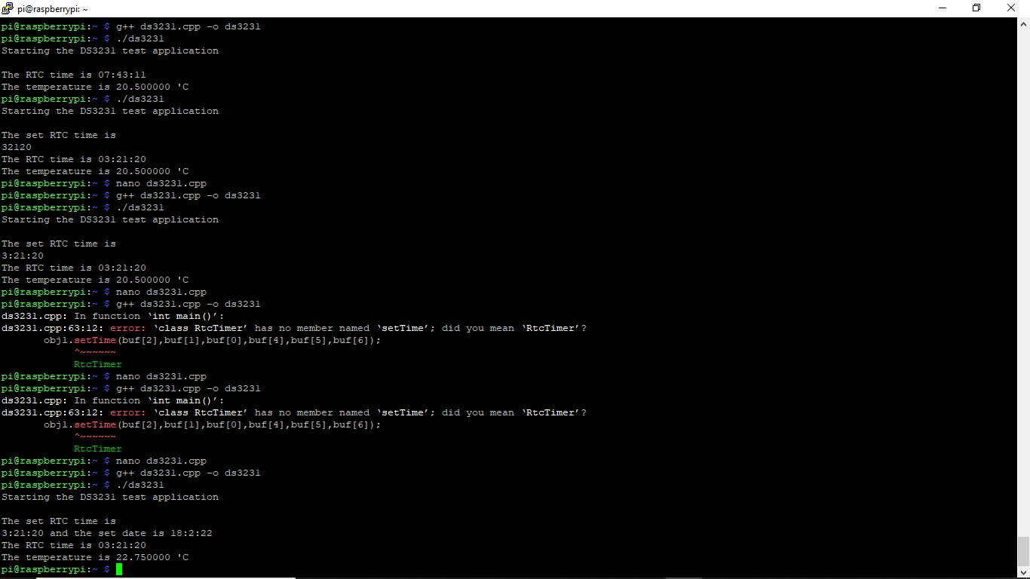

**Set and read the two alarms (please note that there are different types of alarms, e.g., time of day, time on date etc.) Set an RTC interrupt signal due to an alarm condition and evaluate that it works correctly using physical wiring (e.g., drive an LED).** [30%]

The detailed code with comments can be found at <https://github.com/hazimkhwaja/EE513-Assignment_1/blob/main/LEDforAlarm.cpp>

The connection circuit was as follows;

